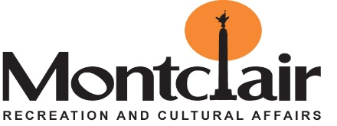
Township of Montclair
Recreation and Cultural Affairs
205 Claremont Ave- Montclair, NJ 07042
973-509-4915- Fax: 973-744-1947
PARK FACILITY PERMIT APPLICATION

DIRECTIONS:
- Fill out application completely.
- Submit application back to the Recreation and Cultural Affairs Department or email mjreaves@montclairnjusa.org .
- If accepted, a park or facility permit will issue an appropriate fee charged.

APPLICANT INFORMATION

__________________________________ _____________________________ __________________________
Company / Organization Contact Person (s) Phone number

_____________________________________________________ Email address: ___________________________________
Street address City / State / Zip

Person Responsible for supervision if different than above ( MUST be present during event )

____________________________________ ______________________________ ______________________________
Name Phone number Alternate number

________________________________________________________ Email address: _________________________________
Street address City / State / Zip

EVENT INFORMATION

Type of activity / event: ___________________________________ Will there be admission charged: Yes No (Circle one)

Name and purpose of event: ___________________________________________________

Park / facility requested ___________________________Alternate park / facility request_____________________________

Date of event: __________________ Start Time: ________ End Time: ________ Estimated attendance: ______

Rain date: ______________________ Start Time: _________End Time: _________

Will there be music? Yes No (if yes, you must answer 1 & 2)

- Type of music: DJ ____Band ____Radio ____ iPod ____ Other _________________

- Will it be amplified? Yes No

***** PARK RULES AND REGULATIONS *****

Township Ordinance 162-2: PROHIBITS:
- Soliciting
- Golf
- Open Fires / Cooking
- Unleashed Dogs
- Alcoholic Beverages
- Motorized Vehicles
- Glass Containers

________________________________ Date ___________ ___________________________________ Date:_________
Signature of Applicant Authorized signature of approval

Fee (In accordance with MRCA policy) $ ______________

